# Module-3 Detection

The key to analyzing and understanding the performance of digital transmission is the realization that signals used in communications can be expressed and visualized graphically. Geometric representation of signals with finite energy provides a mathematically elegant and highly insightful tool for the study of data transmission. Thus, we need to understand signal space concepts as applied to digital communications

## Conceptual model of Digital Communication:



Vector

transmitter

Modulator

Waveform

Channel

Detector

Noise

Vector receiver

Message source

Fig(1) Digital Communication block diagram

A message source emits one symbol every T seconds, with the symbols belonging to an alphabet of M symbols denoted by m1, m2 ,.. . , mM

* A priori probabilities p1, p2, . . . , pM specify the message source output probabilities.
* If the M symbols of the alphabet are equally likely, we may express the probability that symbol m, is emitted by the source as:

#### Pi=P(mi)=1/M for i=1,2,3…M

The transmitter takes the message source output *m*, and codes it into a distinct signal *si(t)* suitable for transmission over the channel.

* The signal *si(t)* occupies the full duration T allotted to symbol m.
* Most important, *si(t)* is a real‐valued energy signal (i.e., a signal with finite energy), as shown by:

*T*

*i*

*Ei* 

⇩ *S* 2 (*t*)*dt*

0

i=1,2, M

The channel is assumed to have two characteristics:

1. The channel is linear, with a bandwidth that is wide enough to accommodate the transmission of signal si(t) with negligible or no distortion.
2. The channel noise, w(t), is the sample function of a zero mean white Gaussian noise process. We refer to such a channel as an additive white Gaussian noise (AWGN) channel. Accordingly, we may express the received signal x(t) as

#### X(t)=Si(t)+w(t)

0  *t*  *T* ,*i*  1,,2,3...*M*

The receiver has the task of observing the received signal x(t) for a duration of T seconds and making a best estimate of the transmitted signal si(t) or, equivalently, the symbol ***mi.*** However, owing to the presence of channel noise, this decision‐making process is statistical in nature, with the result that the receiver will make occasional errors.

* The requirement is therefore to design the receiver so as to minimize the average probability of symbol error, defined as:

*Pe*  *p*(*m*ˆ  *mi* )

## Geometric Representation of Signals

The essence of geometric representation of signals is to represent any set of M energy signals

{***si(t)***} as linear combinations of N orthonormal basis functions, where N ≤ M. That is to say, given a set of real‐valued energy signals ***s1(t), s2(t), ..., sM(t),***each of duration T seconds, we write

{

*N*

*si* (*t*)  *Sij* *j* (*t*),

*j**i*

0*t**T i*1,2,.. *M*

Where the coefficients of the expansion are defined by:

*T*

*sij*   *si* (*t*)* j* (*t*)*dt*

0

*i*1,2,... *M*

{

*j*`1,2,... *N*

The real‐valued basis functions are orthonormal which means

*T*

*sij*  *i* (*t*)* j* (*t*)*dt*

0

1 *if*

0 *if*

{

*i* *j i* *j*

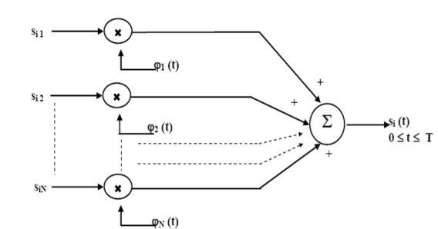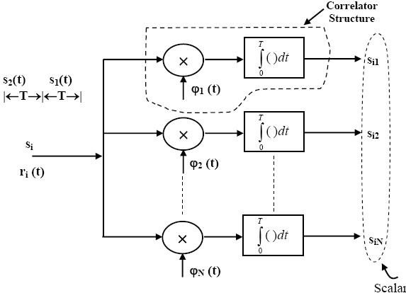The set of coefficients may naturally be viewed as an N dimensional vector, denoted by ***si*** . The important point to note here is that the vector ***si*** bears a one to one relationship with the Transmitted signal

Fig(2) (a)Construction of signal from basis functions, (b) Getting coefficients from Basis functions

**Signal Vector**: We may state that each signal is completely determined by the vector of its coefficients

 *si*1 

 

*s*

 *i* 2 

*si*   . ,

 

 . 

*i*  1,2, *M*

*siN* 

**Signal Space**: The N‐Dimensional Euclidean space constructed using basis functions as mutually perpendicular axis is called the signal space.

**Length**: In an N‐dimensional Euclidean space, it is customary to denote the length (also called the

**absolute value or norm**) of a signal vector ***si*** by the symbol 

**Squared Length**: The squared‐length of any signal vector ***si*** is defined to be the **inner product** or

**dot product of *si***, with itself, as shown by:

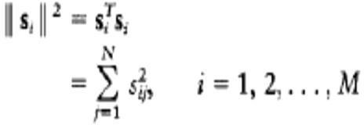

* The inner product of the signals ***si(t)*** and ***sk(t)*** over the interval [0, T] is defined as:

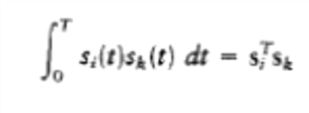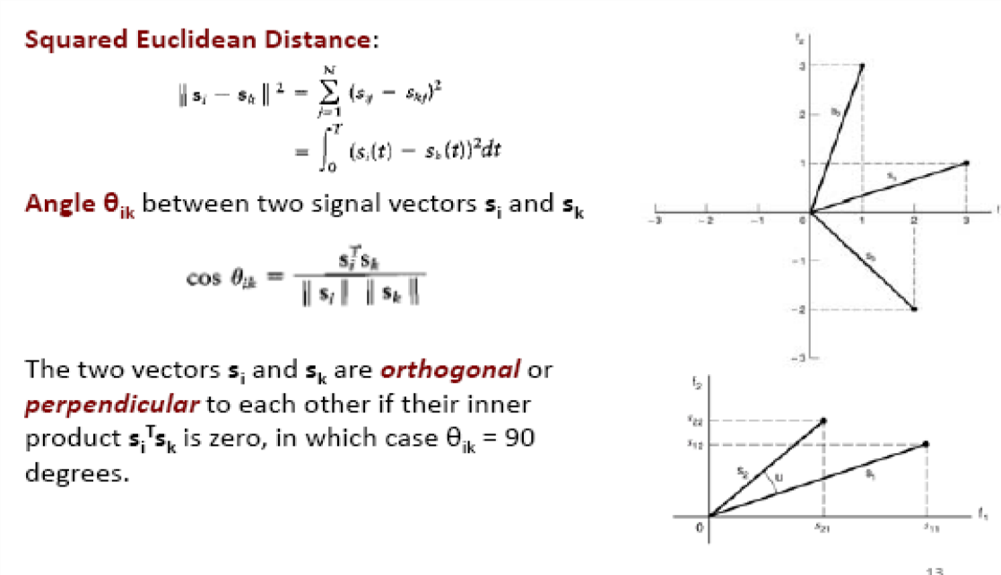

# - -

## Gram Schmidt Orthogonalization procedure:

**As per G-S-O** procedure any given set of energy signals, {si (t)}, 1 ≤ i ≤ M over 0 ≤ t < T, can be completely described by a subset of energy signals whose elements are linearly independent. In part 1, we are eliminating dependent signals from the set.

### Part – I:

To start with, let us assume that all si(t) are not linearly independent. Then, there must exist a set of coefficients {ai}, 1 < i ≤ M, not all of which are zero, such that, a1s1(t) + a2s2(t) + …… + aMsM(t)

= 0, 0 ≤ t < T

Verify that even if two coefficients are not zero, e.g. a1 ≠ 0 and a3 ≠ 0, then s1(t) and s3(t) are dependent signals.

Let us arbitrarily set, aM≠ 0. Then,

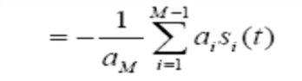

The above equations shows that sM(t) could be expressed as a linear combination of other si(t), i = 1, 2, .., (M – 1).

We need to check in a similar way any dependent signals are there in the given signal set and eliminate them. Now we are left with signal set which contain only independent signals.

**Part – II :** We now show that it is possible to construct a set of ‘N’ orthonormal basis functions

1(t), 2(t), ….., N(t) from {si(t)}, i = 1, 2, ….., N. Let us choose the first basis function as,

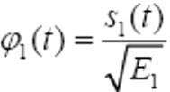

where E1 denotes the energy of the first signal s1(t)

Where

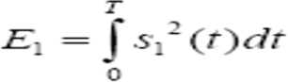

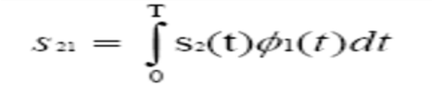Now we can write

Let us now define an intermediate function:

Here g2(t) is orthogonal to the first basis function. This gives us a clue to determine the second basis function.

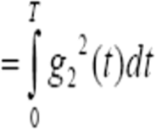Now, energy of g2(t):

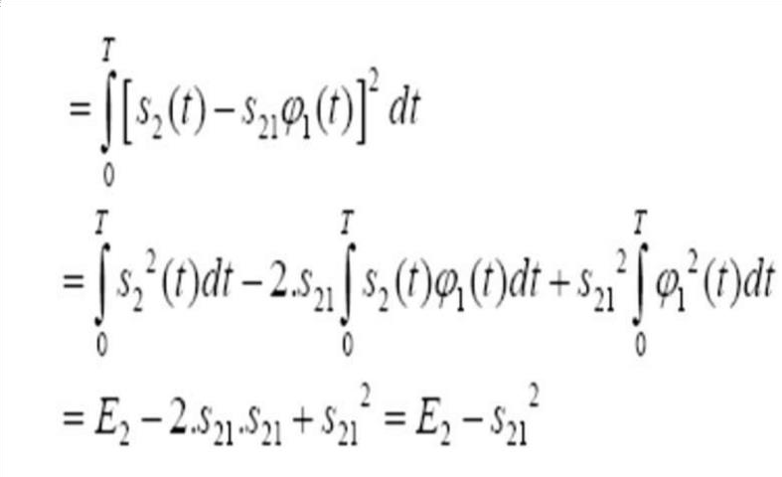

So, we now set,

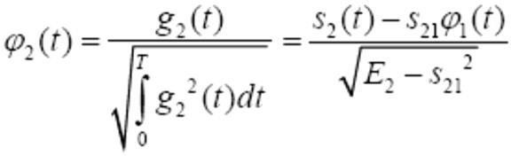

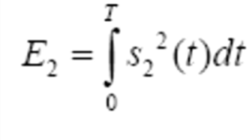

Proceeding in a similar manner, we can determine the third basis function, 3(t). For i=3,

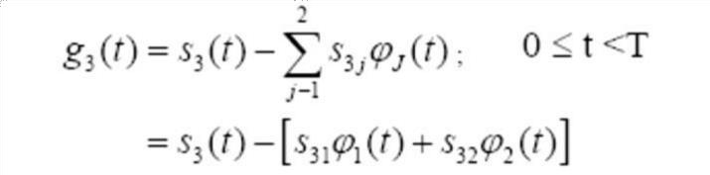

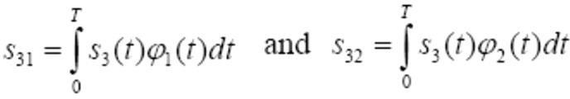

It is now easy to identify that,

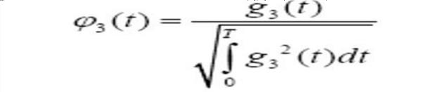

Indeed, in general,

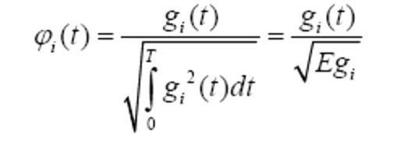for i = 1, 2,….., N, where

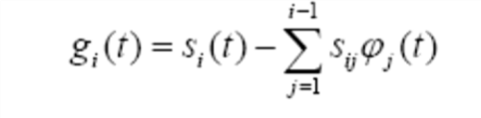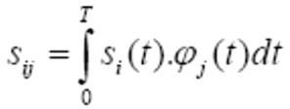

for i = 1, 2,….., N and j = 1, 2, …, M

Summarizing the steps to determine the orthonormal basis functions following the Gram Schmidt Orthogonalization procedure:

If the signal set {sj(t)} is known for j = 1, 2,….., M, 0 ≤ t <T,

* + - Derive a subset of linearly independent energy signals, {si(t)},i = 1, 2,….., N ≤ M.
    - Find the energy of s1(t) as this energy helps in determining the first basis function 1(t), which is a normalized form of the first signal. Note that the choice of this ‘first’ signal is arbitrary.
    - Find the scalar ‘s21’, energy of the second signal (E2), a special function ‘g2(t)’ which is orthogonal to the first basis function and then finally the second orthonormal basis function 2(t)
    - Follow the same procedure as that of finding the second basis function to obtain the other basis functions.

## Concept of signal space

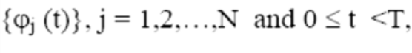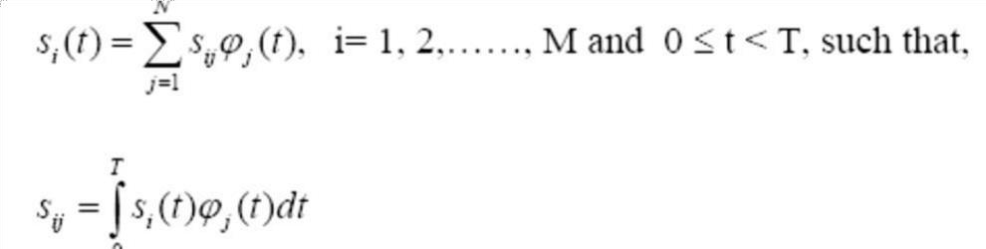Consider a set of basis functions

Now, we can represent a signal si(t) as a column vector whose elements are the scalar coefficients sij, j = 1, 2, ….., N :

These M energy signals or vectors can be viewed as a set of M points in an N – dimensional Euclidean space, known as the ‘*Signal Space’ Signal Constellation* is the collection of M signals

points (or messages) on the signal space.

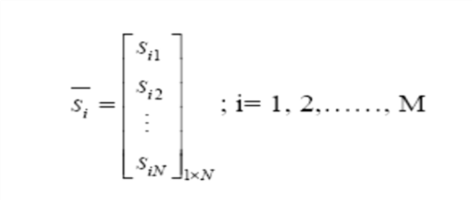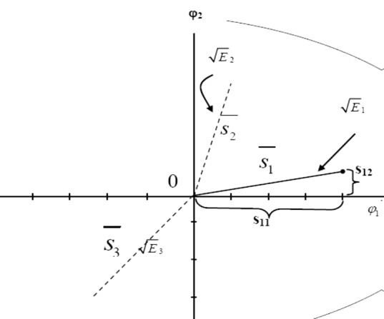

Fig(3) Signal space representation

## Problem:

**Use the Gram-Schmidt procedure to find a set orthonormal basis functions corresponding to the signals show below:** Express x1, x2, and x3in terms of the orthonormal basis functions. Draw the constellation diagram for this signal set

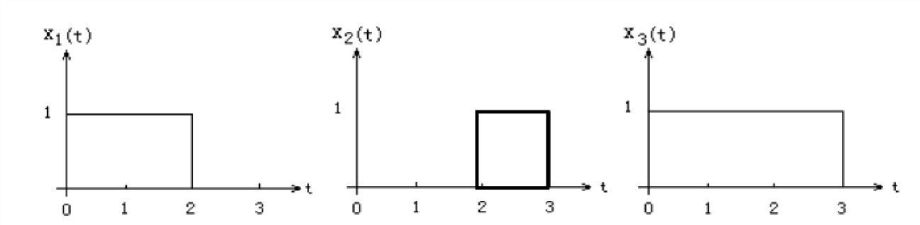

Step 1: Eliminate dependent signals from the set.

Stage1: Here x3(t)=x1(t)+x2(t), so x3(t) is dependent signal and eliminate it from the set. Remaining signals {x1(t),x2(t)}

Hence two basis functions exits for this signal set. First two basis functions are calculated as shown in step1 and step 2.

Then received signal point in signal space is calculated by finding coefficients Sij

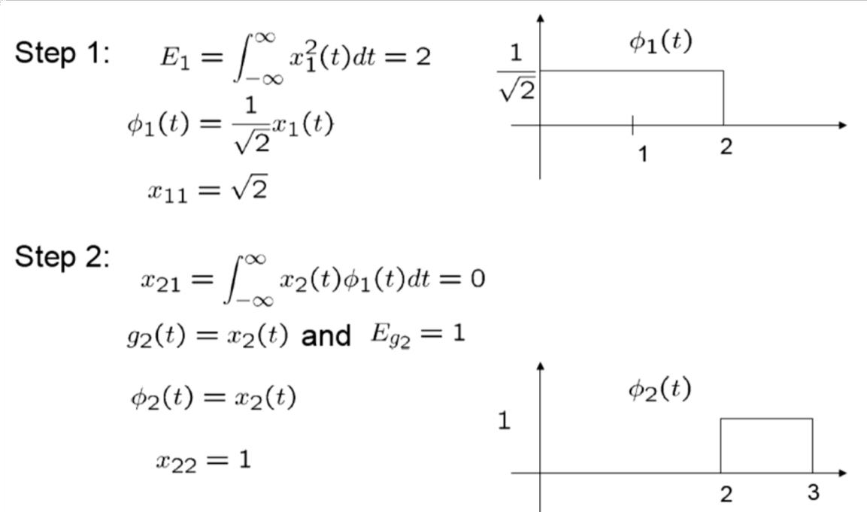

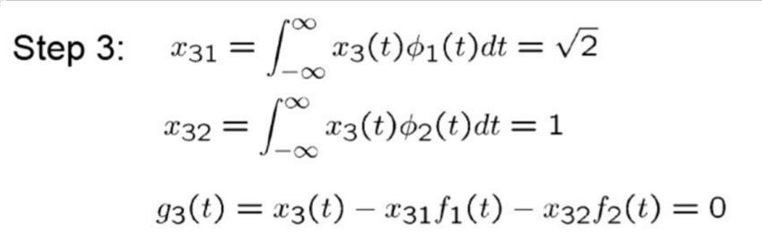

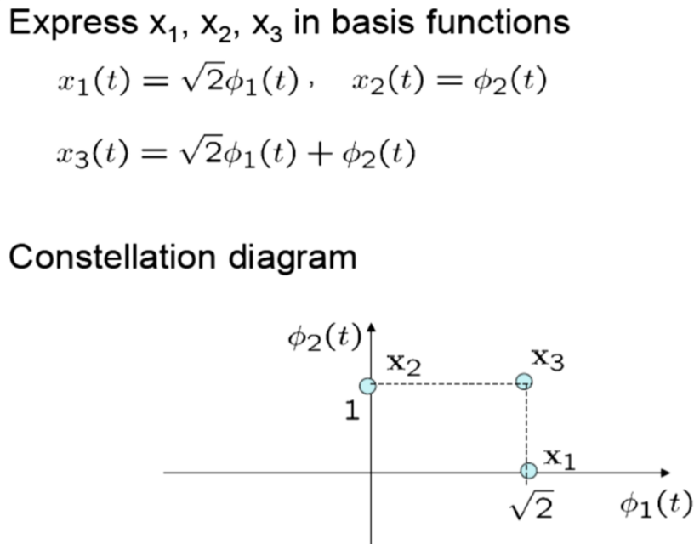

## Use of Signal Space for Signal Detection in a Receiver:

The signal space defined above is very useful for designing a receiver as well. In a sense, much of the features of a modulation scheme, such as the number of symbols used and the energy carried by the symbols, is embedded in the description of its signal space. So, in absence of any noise, the receiver should detect one of these valid symbols only. However, the received symbols are usually corrupted and once placed in the signal space, they may not match with the valid signal points in some respect or the other. Let us briefly consider the task of a good receiver in such a situation. Let us assume the following:

1. One of the M signals si(t), i=1,2,….,M is transmitted in each time slot of duration ‘T’ sec.
2. All symbols are equally probable, i.e. the probability of occurrence of si(t) = 1/M, for all ‘i’. 3. Additive White Gaussian Noise (AWGN) processes W (t) is assumed with a noise sample function w (t) having mean = 0 and power spectral density 0N2 [N0: single sided power spectral density of additive white Gaussian noise. Noise is discussed more in next two lessons] 4. Detection is on a symbol-by-symbol basis.

Now, if R (t) denotes the received random process with a sample function r (t), we may write, r(t)=s(t)+w(t) ; 0 ≤ t < T and i = 1,2,….,M

The job of the receiver is to make “best estimate” of the transmitted signal si (t) (or, equivalently, the corresponding message symbol mi) upon receiving r(t). We map the received sample function

r(t) on the signal space to include a ‘received vector’ or ‘received signal point’. The detection problem can now be stated as:

#### ‘Given an observation / received signal vector (r), the receiver has to perform a mapping from r an estimate for m, the transmitted symbol in a way that would minimize the average probability of symbol error’.

## Correlation Receiver:

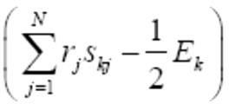A *Correlation Receiver*, consisting of a Correlation Detector and a Vector Receiver implements the M – L decision rule stated above by,

1. first finding *r*ˆ with a correlation detector and then
2. Computing the metric and taking decision in a vector receiver.

Fig5. Below shows the structure of a Correlation Detector for determining the received vector *r* from the received signal r(t). Fig6 highlights the operation of a Vector Receiver.

In the correlation detector, multiply received signal with different basis functions and integrate the product to identify the correlation between the received signal and individual basis function and form the received vector.

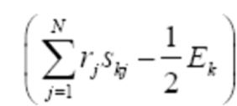The vector receiver is constructed based on ML detection as per the equation

Decision is made by selecting the signal with maximum likelihood value.

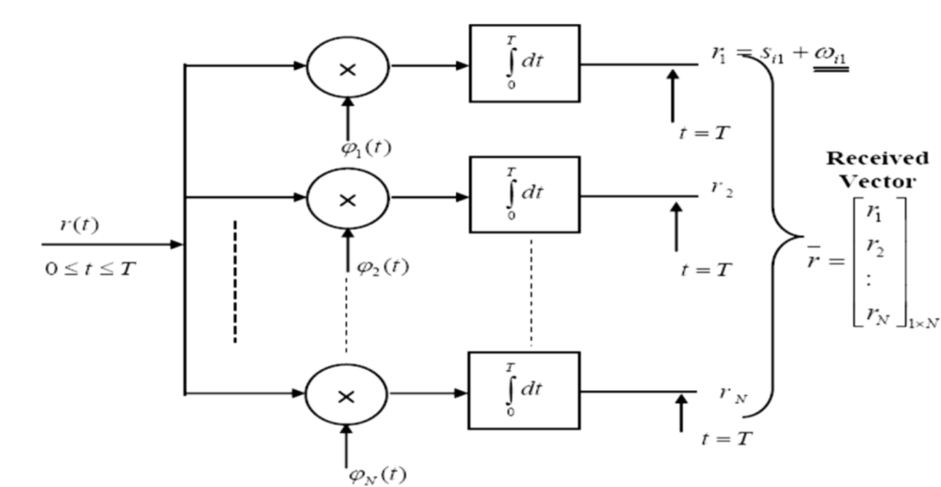

Fig(5) The structure of a Correlation Detector

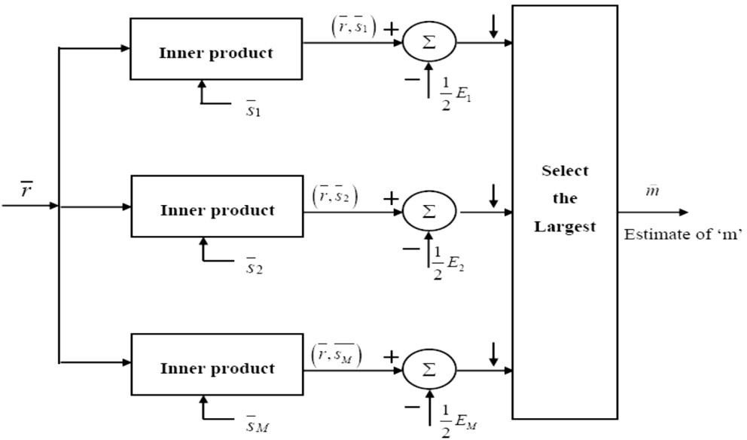

Fig(6) Block schematic diagram for the Vector Receiver

## Matched Filter Receiver:

Certain structural modification and simplifications of the correlation receiver are possible by observing that,

1. All orthonormal basis functions j are defined between 0 ≤ t ≤ Tb and they are zero outside this range.
2. Analog multiplication, which is not always very simple and accurate to implement, of the received signal r(t) with time limited basis functions may be replaced by some filtering operation. Let, hj(t) represent the impulse response of a linear filter to which r(t) is applied.

Then, the filter output Yj(t) may be expressed as:

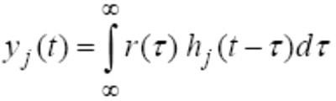

Now, let

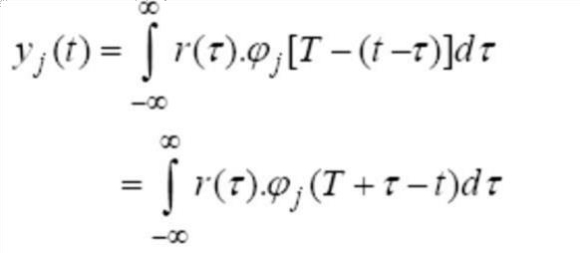

If we sample this output at t = T, and recalling that j(t) is zero outside the interval 0≤ *t* ≤*T* Using this, the above equation may be expressed as,

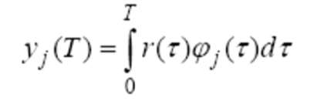

From our discursion on correlation receiver, we recognize that,

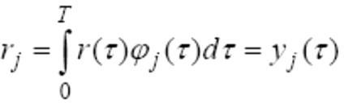

The important expression of above equation is that it tells us that the jth correlation output can equivalently be obtained by using a filter with hj(t)=j(T-t) and sampling its output at t = T.

**The filter is said to be matched to the orthonormal basis function j(t) and the alternate receiver structure is known as a matched filter receiver**. The detector part of the matched filter receiver is shown in fig below.

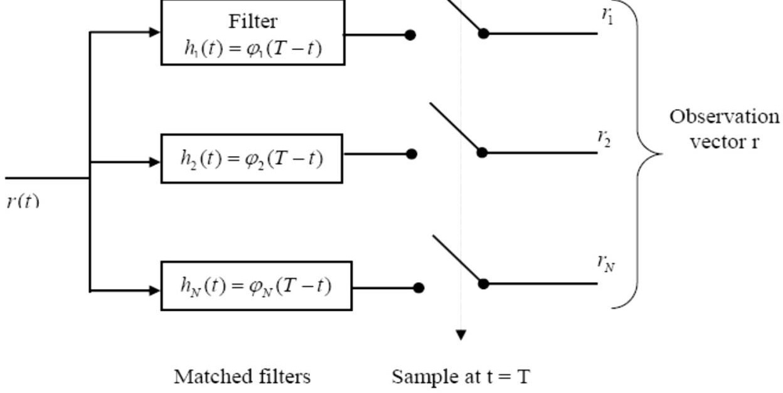

Fig(7)The block diagram of a matched filter bank that is equivalent to a Correlation Detector

### A physically realizable matched filter is to be causal i.e hj(t)=0 for t<0.

**Properties of a Matched Filter**

We note that a filter which is matched to a known signal (*t)*,0 ≤t≤T is characterized by an impulse response h(t) which is a time reversed and delayed version of (*t*) i.e.



hj(t)= j(T-t)

In the frequency domain, the matched filter is characterized by a transfer function, which is, except for a delay factor, the complex conjugate of the F.T. of  (*t*), i.e.



**Property (1) :** The spectrum of the output signal of a matched filter with the matched signal as input is, except for a time delay factor, proportional to the energy spectral density of the input signal.

Let, Φ0(f) denote the F.T. of the filter of output Φ0(t). Then,

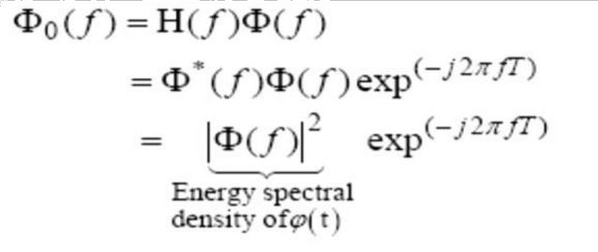

**Property (2):** The output signal of a matched filter is proportional to a shifted version of the autocorrelation function of the input signal to which the filter is matched.

This property follows from Property (1). As the auto-correlation function and the energy spectral density form F.T. pair, by taking IFT of above equation, we may write,

Where RФ(τ) is ACF of Φ0(t). At t=T, we get R(0)=energy of the signal.

**Property (3):** The output SNR of a matched filter depends only on the ratio of the signal energy to the psd of the white noise at the filter input.

Let us consider a filter matched to the input signal Φ(t)

From property (2), we see that the value of Φ0(t)at t=T is 0(T-t)=E

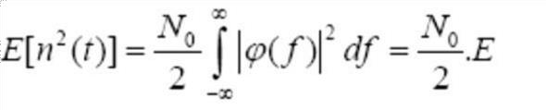Now, it may be shown that the average noise power at the output of the matched filter is given by,

The maximum signal power

Hence

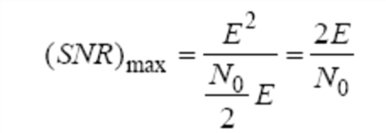

Note that SNR in the above expression is a dimensionless quantity.

This is a very significant result as we see that the *SNR*max depends on E and N0 but not on the shape of (*t*) This means a freedom to the designer to select specific pulse shape to optimize other design requirement (the most usual requirement being the spectrum or, equivalently, the transmission bandwidth) while ensuring same SNR.

**Property (4):** The matched-filtering operation may be separated into two matching condition: namely, spectral phase matching that produces the desired output peak at t = T and spectral amplitude matching that gives the peak value its optimum SNR.

The filter is said to be matched to the signal  (*t*) in spectral phase if the transfer function of the filter follows:



Here Η (*f*) is real non-negative and ‘T’ is a positive constant. The output of such a filter is,

